# FacebookGetRefreshTokenStep

**Objective:**

It is used to get refresh token for facebook.

**Attributes:**

|  |  |
| --- | --- |
| **Attributes** | **Description** |
| access_token | To enter the facebook access token |
| output_variable | Used to store the response of the request |
| plugin_name | Which have been configured for facebook oauth |
| value_type | To select type as free marker template or handlebar |

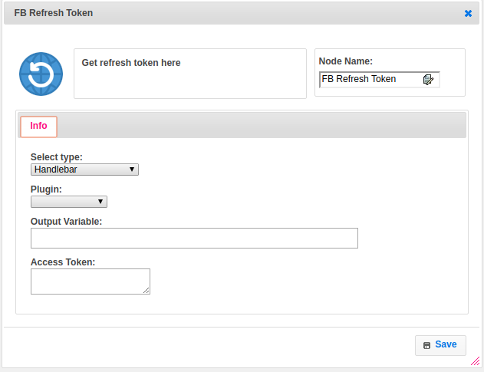

**Executor Description:**

In executor class first forms the url to get refresh token and need to append required query parameters for that rest url. Build method is get and it make new get call to server